**Hospital Management System Project   
 Documentation**

**Table of Contents**

1. About the Project
2. System Architecture
3. Entity-Relationship (ER) Diagram
4. Modules Description
5. Database Design
6. Sample Screenshots
7. Conclusion

**1. About the Project**

The Hospital Management System (HMS) is a centralized solution intended to streamline and digitalize all core hospital operations, ranging from patient registration to billing and inventory control. The system aims to replace manual processes with secure, accessible digital modules that provide improved data integrity and operational efficiency. Key objectives include:

* Enhanced patient care through quick access to records.
* Efficient management of appointments, billing, and inventory.
* Role-based access for administrators, doctors, staff, and patients.
* Reliable storage and retrieval of medical and administrative data.

**2. System Architecture**

The HMS is typically implemented using a three-tier architecture:

* **Presentation Layer:** The user interface is accessible to all system users including administrators, doctors, staff, and patients, with secure authentication and clear navigation.
* **Application Layer:** Serves as the system's brain, housing business logic for scheduling, billing, and medical data management.
* **Database Layer:** This contains all hospital data—patient records, appointments, inventory, billing—and ensures proper normalization and security.

**Advantages:**

* Separation of concerns.
* Scalability, maintainability, and security.

**3. Entity-Relationship (ER) Diagram**

A robust ER diagram illustrates key system entities and their relationships, including:

* **Patient:** Personal info, admission details, medical history.
* **Doctor:** Professional details, specialization, schedules.
* **Appointment:** Connects patients and doctors with time and date slots.
* **Staff:** Nurses, technicians, administrative personnel.
* **Billing:** All transaction and payment records.
* **Room:** Ward or room details with allocation status.
* **Medical Records:** Detailed diagnostics, test results, and treatments.
* **Inventory/Pharmacy:** Medicine stock and hospital supplies.  
    
    
    
  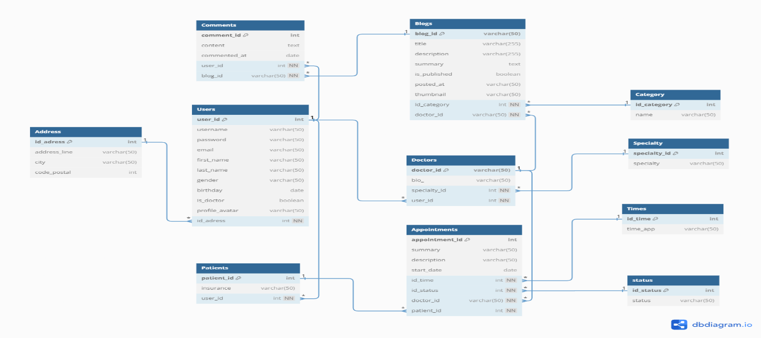

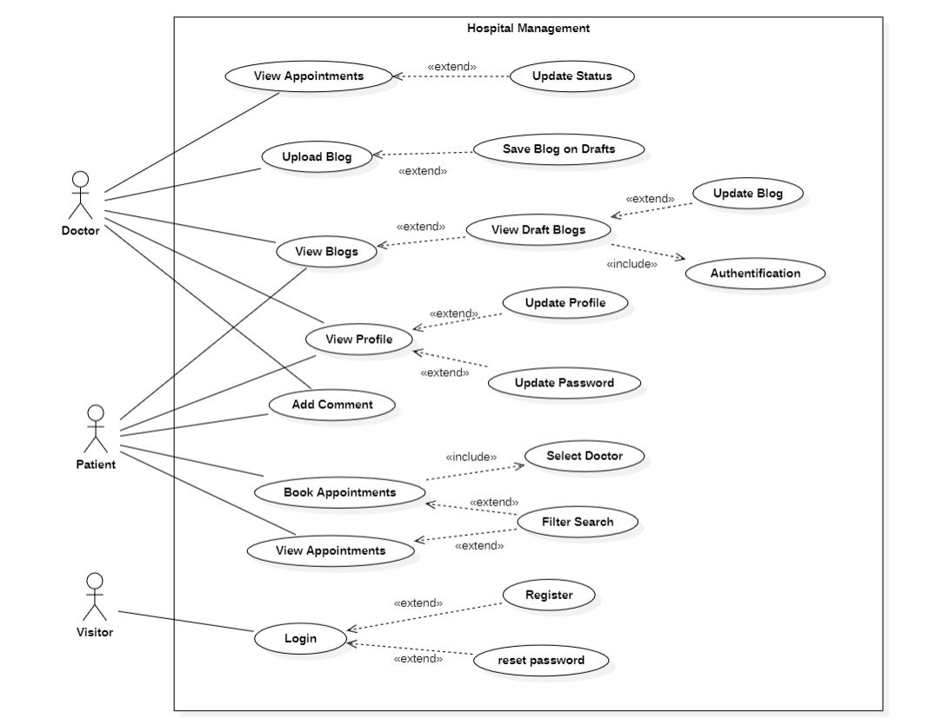

**4. Modules Description**

**Core Modules**

* **Patient Management**
  + Registration, upload/view history, manage appointments, view reports.
* **Doctor Management**
  + Scheduling, appointments, specialization records.
* **Appointment Management**
  + Automated booking/rescheduling, reminders.
* **Billing & Payment**
  + Generation of bills, payment tracking, insurance claims.
* **Inventory Management**
  + Track consumables and equipment, low-stock alerts.
* **Lab & Diagnostics**
  + Test assignments, sample routing, results.
* **Pharmacy Management**
  + Medicine inventory, prescription management, dispensing log.
* **Ward/Room Management**
  + Patient allocation, room/bed management, status tracking.
* **Administrative Module**
  + Staff records, payroll, policy and system configuration.

**5. Database Design**

A normalized relational schema ensures integrity and efficient access. Key tables include:

|  |  |
| --- | --- |
| Table | Key Fields |
| Patient | PatientID, Name, DOB, Address, Contact, MedicalHistory |
| Doctor | DoctorID, Name, Specialization, Contact, Schedule |
| Appointment | AppointmentID, PatientID, DoctorID, Date, Time, Status |
| Staff | StaffID, Name, Role, Department |
| Billing | BillID, PatientID, Date, Amount, Status |
| Room | RoomID, Type (ICU/Ward), Status, PatientID (if allocated) |
| MedicalRecord | RecordID, PatientID, DoctorID, Diagnosis, Prescriptions, TestResults |
| Inventory | ItemID, ItemName, Quantity, ExpiryDate, Supplier |
| Prescription | PrescriptionID, PatientID, DoctorID, Date, MedicineDetails |

**6. Sample Screenshots**

While screenshots cannot be displayed in document format here, standard HMS interfaces typically include:

* **Login Page:** Secure access with role selection.
* **Patient Dashboard:** Appointments, billing, and medical records at a glance.
* **Appointment Scheduling:** Calendar and doctor availability.
* **Billing Page:** Invoice generation and payment summaries.
* **Inventory Management:** Medicine/supply lists with automatic reorder triggers.
* **Admin Dashboard:** Alerts, statistics, and operation overview.

**7. Conclusion**

Implementing a Hospital Management System brings efficiency, security, and accuracy to all levels of hospital operations. Its modular structure is adaptable to different hospital sizes and specialties, ensuring support for current and future healthcare needs. Automation and digitalization through HMS significantly reduce manual errors, enhance patient care, and improve overall workflow in a secure and user-friendly environment.